Cross-quantilogram: GBPUSD and USDCAD
Method 20 / daily log returns / expanding quantiles / Alpari D1 full available history

Study setup
Logical pair: GBPUSD , USDCAD
Broker symbols: GBPUSD_i , USDCAD_i
Snapshot: 2026-11-03_majors_alpari_D1
Timeframe: D1
Matched return window: 1999-01-05 to 2026-11-02 (UTC bar dates)
Matched return count n: 7205
Dropped unfinished last bar dated 2026-11-03 UTC after a tick-volume check against the prior complete day.
Quantiles: expanding window, min history 252 days
tau in [0.05, 0.2]; k=0..10; headline tau=0.05, k=1
Complete matched rows (Excel): GBPUSD-USDCAD_CQ_D1.xlsx
Complete matched rows (HTML table): GBPUSD-USDCAD_CQ_D1_data.html

Method carried forward
The cross-quantilogram rho_tau(k) measures linkage among centered quantile-hit indicators of matched daily log returns of close, ln(close_t / close_t-1). Quotes are not inverted. At each date t, the tau-quantile uses only returns through t (expanding window) after a minimum history of 252 days. Hits are h_t = 1(r_t < q_t) - tau. rho_tau(k) is the normalized cross-product of h_x,t with h_y,t+k. Levels tau in {0.05, 0.20} and lags k=0..10 are pre-specified; headline is tau=0.05, k=1 both directions. Same-sample Pearson r is a side check. This is not causation and not a trading signal.

Results (headline)
rho_GBPUSD->USDCAD(tau=0.05,k=1): 0.074110
rho_USDCAD->GBPUSD(tau=0.05,k=1): 0.033153
rho_GBPUSD->USDCAD(tau=0.20,k=1): 0.038880
rho_USDCAD->GBPUSD(tau=0.20,k=1): 0.001731
Pearson r: -0.456462

CQ table (tau=0.05)
k | rho_GBPUSD_to_USDCAD | n_GBPUSD_to_USDCAD | rho_USDCAD_to_GBPUSD | n_USDCAD_to_GBPUSD
0 | -0.03119994 | 6954 | -0.03119994 | 6954
1 | 0.07410954 | 6953 | 0.03315292 | 6953
2 | 0.03899684 | 6952 | 0.03022035 | 6952
3 | 0.02454062 | 6951 | 0.04776636 | 6951
4 | 0.04503907 | 6950 | 0.0009508 | 6950
5 | 0.08018479 | 6949 | 0.01557128 | 6949
6 | 0.05381333 | 6948 | 0.0418943 | 6948
7 | 0.03037092 | 6947 | 0.03018489 | 6947
8 | 0.0450111 | 6946 | 0.02140093 | 6946
9 | 0.03328619 | 6945 | 0.0096912 | 6945
10 | 0.03913811 | 6944 | 0.05356893 | 6944

Conclusion
Headline tau=0.05, k=1 for GBPUSD and USDCAD: rho_GBPUSD->USDCAD = 0.0741; rho_USDCAD->GBPUSD = 0.0332. At tau=0.20, k=1: 0.0389 and 0.0017. Same-day tau=0.05 rho(k=0) = -0.0312. Pearson r = -0.4565. This is quantile-hit linkage, not a trading signal.

Charts
Daily closes

Daily log returns

Cross-quantilogram tau=0.05
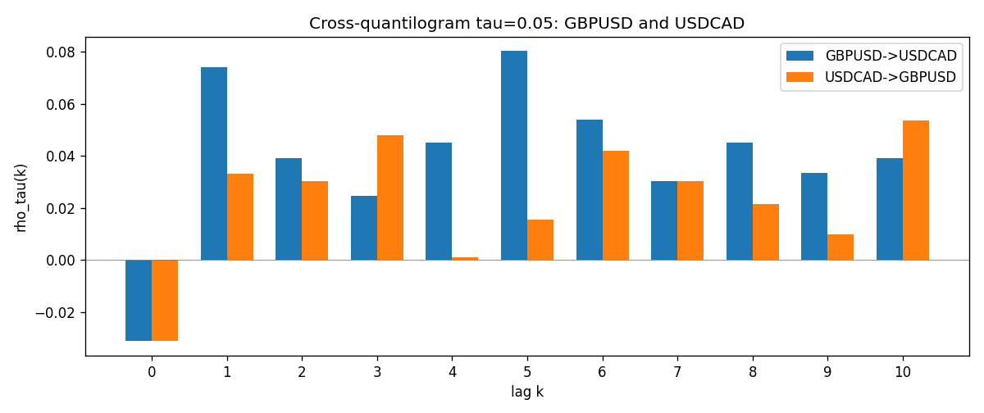

Data report
Matched rows and the CQ sheet are in the sibling Excel workbook named GBPUSD-USDCAD_CQ_D1.xlsx. Embedding all rows as a Word table is impractical; this file holds column summaries and the first and last 15 matched rows.
Columns: time, GBPUSD_open, USDCAD_open, GBPUSD_high, USDCAD_high, GBPUSD_low, USDCAD_low, GBPUSD_close, USDCAD_close, GBPUSD_tick_volume, USDCAD_tick_volume, GBPUSD_spread, USDCAD_spread, GBPUSD_real_volume, USDCAD_real_volume, GBPUSD_log_return, USDCAD_log_return, GBPUSD_h_t005, USDCAD_h_t005
Column summaries (matched calculation rows)
column | count | mean | std | min | 25% | 50% | 75% | max
GBPUSD_open | 7205 | 1.5161639 | 0.2182756 | 1.06854 | 1.32505 | 1.51142 | 1.63205 | 2.1066
USDCAD_open | 7205 | 1.2670469 | 0.16900802 | 0.9168 | 1.119 | 1.29857 | 1.3723 | 1.6183
GBPUSD_high | 7205 | 1.5224596 | 0.21884187 | 1.08366 | 1.32981 | 1.5182 | 1.6384 | 2.1161
USDCAD_high | 7205 | 1.2719479 | 0.16896591 | 0.9336 | 1.1234 | 1.30394 | 1.3769 | 1.619
GBPUSD_low | 7205 | 1.5098441 | 0.21750249 | 1.03518 | 1.31956 | 1.50336 | 1.62444 | 2.0983
USDCAD_low | 7205 | 1.2624879 | 0.16904619 | 0.9056 | 1.1144 | 1.29361 | 1.36793 | 1.6102
GBPUSD_close | 7205 | 1.5162333 | 0.21823062 | 1.06879 | 1.3252 | 1.5114 | 1.6322 | 2.1065
USDCAD_close | 7205 | 1.2670655 | 0.16898286 | 0.916 | 1.11851 | 1.29871 | 1.37253 | 1.6137
GBPUSD_tick_volume | 7205 | 94776.836 | 153518.92 | 62 | 9986 | 52867 | 91739 | 1273370
USDCAD_tick_volume | 7205 | 80835.261 | 147176.39 | 37 | 5509 | 40849 | 71515 | 1410818
GBPUSD_spread | 7205 | 26.978348 | 19.192834 | 0 | 11 | 20 | 50 | 50
USDCAD_spread | 7205 | 23.508952 | 18.282466 | 0 | 9 | 17 | 40 | 60
GBPUSD_real_volume | 7205 | 3.5541156e+09 | 8.441481e+10 | 0 | 0 | 0 | 0 | 2.4038164e+12
USDCAD_real_volume | 7205 | 1.8330194e+10 | 9.6578305e+10 | 0 | 0 | 0 | 0 | 2.5751613e+12
GBPUSD_log_return | 7205 | -2.188e-05 | 0.00563988 | -0.08388241 | -0.00312535 | 3.221e-05 | 0.0031749 | 0.03112653
USDCAD_log_return | 7205 | -1.219e-05 | 0.00514402 | -0.03859748 | -0.00283601 | 4.92e-05 | 0.00272763 | 0.03436319
GBPUSD_h_t005 | 6954 | 0.00148116 | 0.22099293 | -0.05 | -0.05 | -0.05 | -0.05 | 0.95
USDCAD_h_t005 | 6954 | 0.00220017 | 0.22244647 | -0.05 | -0.05 | -0.05 | -0.05 | 0.95
First 15 matched rows (selected columns)
time | GBPUSD_log_return | USDCAD_log_return | GBPUSD_h_t005 | USDCAD_h_t005
1999-01-05 | -0.0028966287 | -0.010131666 | nan | nan
1999-01-06 | -0.00060452184 | -0.0003306769 | nan | nan
1999-01-07 | -0.002118709 | 0.0015202092 | nan | nan
1999-01-08 | -0.0058954193 | -0.0020495197 | nan | nan
1999-01-11 | -0.0056851331 | -0.0035137769 | nan | nan
1999-01-12 | 0.0022657001 | 0.0066194721 | nan | nan
1999-01-13 | 0.0091330396 | 0.0045420214 | nan | nan
1999-01-14 | 0.0019376331 | 0.0069376546 | nan | nan
1999-01-15 | -0.0017558204 | -0.0056905671 | nan | nan
1999-01-18 | 0.0012112405 | 0.00098344542 | nan | nan
1999-01-19 | 0.0018745281 | 0.002748513 | nan | nan
1999-01-20 | -0.0049053846 | -0.0059646885 | nan | nan
1999-01-21 | 0.0031518998 | -0.0042823796 | nan | nan
1999-01-22 | 0.0024781662 | 0.0025057712 | nan | nan
1999-01-25 | 0.0012066366 | 0.00085579808 | nan | nan
Last 15 matched rows (selected columns)
time | GBPUSD_log_return | USDCAD_log_return | GBPUSD_h_t005 | USDCAD_h_t005
2026-10-13 | 0.0036434319 | -0.0046395653 | -0.05 | -0.05
2026-10-14 | -0.0049164679 | 0.0015184751 | -0.05 | -0.05
2026-10-15 | 0.0065976411 | -0.0036101503 | -0.05 | -0.05
2026-10-16 | 0.0037592051 | -0.0034322068 | -0.05 | -0.05
2026-10-19 | -0.0017500314 | -0.0018835331 | -0.05 | -0.05
2026-10-20 | 0.0055923442 | -0.0037066008 | -0.05 | -0.05
2026-10-21 | 0.0012476328 | -0.00084691787 | -0.05 | -0.05
2026-10-22 | 0.00022396082 | -0.0026307268 | -0.05 | -0.05
2026-10-23 | -0.0021146949 | 2.85545e-05 | -0.05 | -0.05
2026-10-26 | -0.0024340661 | 5.7106554e-05 | -0.05 | -0.05
2026-10-27 | -0.0023648393 | 0.0025379458 | -0.05 | -0.05
2026-10-28 | 0.0015771808 | -0.0038379274 | -0.05 | -0.05
2026-10-29 | 0.0035881935 | -0.00011436495 | -0.05 | -0.05
2026-10-30 | 0.0013450605 | -0.0010298736 | -0.05 | -0.05
2026-11-02 | 0.0010971256 | 0.00061519094 | -0.05 | -0.05

